Trisia May Baltazar

CIS 310-02

Exercise A1

Due 8/30/17

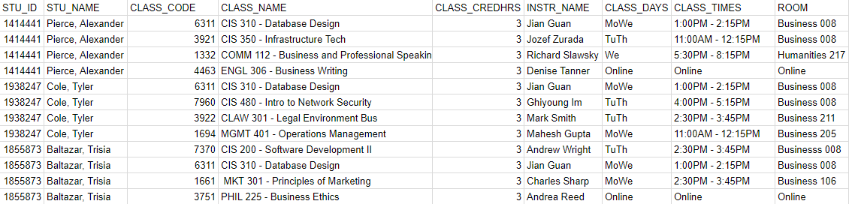

1. There are a lot of repetition on each section of the table. A couple redundancies are student IDs, name, and class credit hours. They are redundant because it’s the same information repeated unnecessarily. All credit hours are also 3 hours. Class codes, names and instructor names also repeat but each instructor has multiple classes, codes, days and time that separate them from each other (although they may share the same days, they may have different times, or different rooms).
2. Perhaps a student got married and the last name in the student name needed to be change. It would need to changed four times (in the case of our spreadsheet) or it would create an update anomaly. If a student is deleted, and if he or she is the only person in the database that is taking the class (which is true for most of our spreadsheet), all information about that class would be lost and thus create a deletion anomaly.